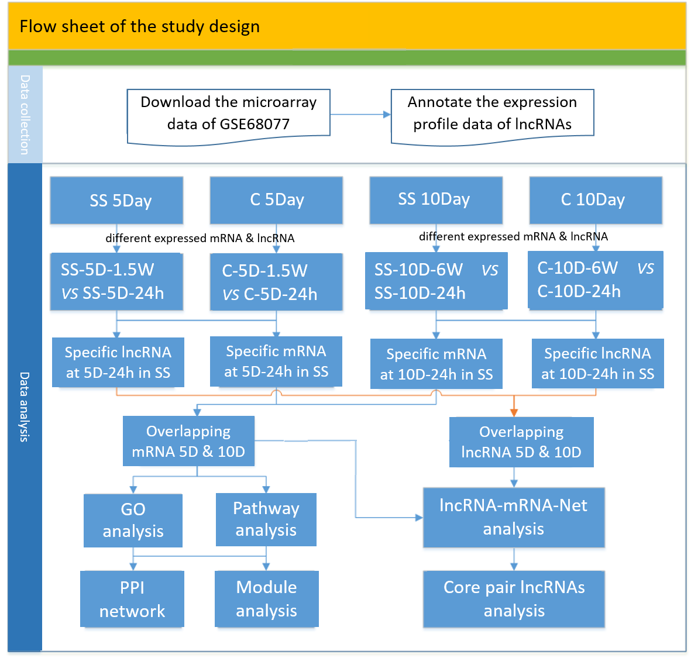
The experiment design of our study is presented as follows:

Note: SS represents social stressed (SS) group, and C represents control group. 5Day or T5D represents 5 days traumatic exposure, and 10Day or T10D represents 10 days traumatic exposure. 24h, 1.5W and 6W represents 24 hours, 10 days and 42 days home cage rest, respectively.

There were four steps to identify the finally DEGs. Firstly, DEGs at four different time points (1 day or 10 days after 5-day aggressor exposed, T5R1, T5R10; 1 day or 42 days after 10-day aggressor, T10R1, T10R42) were identified in social stressed (SS) groups and control (C) groups, respectively. Secondly, DEGs at two time points (5 days and 10 days traumatic exposure) in two groups (SS and C) were identified using Venn online tool, respectively. The overlapping DEGs of different home cage rest at 5 and 10 traumatic exposure in SS and C were obtained. Thirdly, we compared the DEGs of two groups (SS and C) at T5D and T10D, respectively. The specific DEGs at T5D or T10D in SS group were identified. Finally, DGEs at T5D and T10D were overlapped, which were used for further analysis.
Among these identified genes, some were high expressed or low expressed at both 5 days and 10 days trauma exposed, while the others were high expressed or low expressed at either 5 days or 10 days trauma exposed. The down and up regulated genes (lncRNAs and mRNAs) were analyzed in the following functional pathway analyses, PPT network construction and co-expression analyses.
Taken lncRNAs for example. We annotated lncRNAs from chip data of GPL7202. Three databases such as NCBI (transcripts beginning with NR, XR), Ensembl, NONCODEv5 were selected and the non-protein-coding transcripts longer than 200 nt were used for comparison database. After Blast comparison, the lncRNAs of four different time points (1 day or 10 days after 5-day aggressor exposed, T5R1, T5R10; 1 day or 42 days after 10-day aggressor, T10R1, T10R42) were identified in social stressed (SS) groups and control (C) groups, respectively. Under the criteria of |fold change|＞1.5 and P-value< 0.05, the differentially expressed lncRNAs of four time points (T5R1, T5R10, T10R1, T10R42) in two groups (SS, C) were obtained. Then, the overlapping differentially expressed lncRNAs of two time rest periods (24h, 1.5w) following 5 days or two time rest periods (24h, 6w) following 10 days trauma-exposed were identified by Venn online tool. As Figure 2A in the manuscript showed, there were 310 differentially expressed lncRNAs in C group, and 222 lncRNAs in SS group at 5 days trauma exposure. While in 10 days trauma exposure, the lncRNAs were 615, 394 in SS groups and C groups, respectively. Next, we got the specific lncRNAs at 5 or 10 days trauma exposed, that was 218 and 606, respectively. Finally, the two group lncRNAs (5 and 10 days trauma exposed in SS) were overlapped by Venn online tools. And 45 overlapping lncRNAs in both T5d and T10d were identified for further analysis.

